Consultants’ Guide to the Project Tracking Application

Last revised by James Midkiff – April 2019

# Table of Contents

* Purpose
* Start-Up
* Main Menu
* Open Projects Form
* Consultants Form
* Clients Form
* Analysts Form
* Project History Form
* Update Project Form
* Add New Project Form
* Having Multiple Forms Open
* Troubleshooting
* Field Definitions

# Purpose

The Project Tracking Application is designed to:

* Give consultants, Subject Matter Experts (SMEs), and analysts a user-friendly, streamlined means of viewing the current status of the projects they are working on
* Give managers an overview of what their team members are working on
* Ensure that everyone can see the most up-to-date information about a project simultaneously
* Provide an easy way for multiple people to update a project’s status or add a new project

The application consists of several linked forms that pull information from tables within the database.

Please review screenshot numbers 1-8 in the Screenshots folder on the google drive link while reviewing this guide.

# Start-Up

If you have not accessed the database before **OR** if the database has been renamed or moved to a different file location, you must enable the database. If you do not enable it, the application will not work. To do that:

#### Most Computers

* 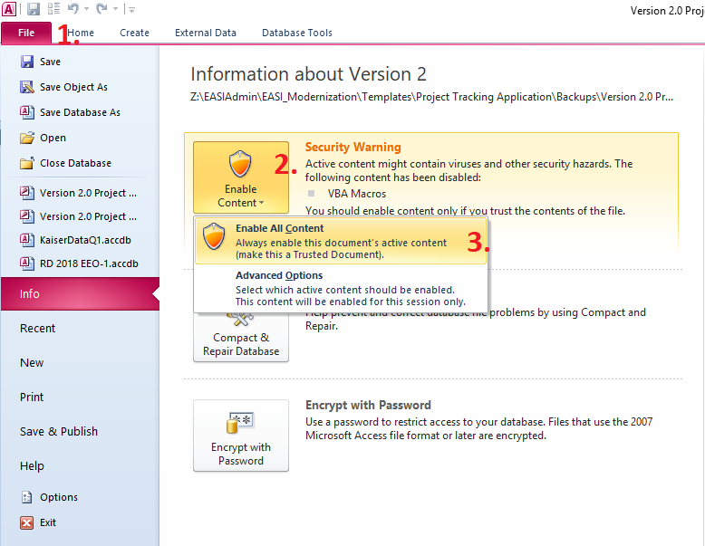Go to File > Enable Content > and click ‘Enable All Content’.
* The application is now ready to use. Simply close the database when finished

#### Some Computers

* Some computers instead offer a yellow bar across the top of the database that says “Click to Enable Content”
* Click that button to enable the database. You then do not need to follow the directions under the section *Most Computers*.

# Main Menu

The Main Menu form auto-starts with the database. From it, you can access each of the application’s main functions.

### View Project Buttons

Each of these buttons will close the Main Menu form and open the form selected. These specific forms are read-only with respect to all data. See the section *Field Definitions* for a definition of each field and the options you can choose for certain fields.

* View All Projects – Open Projects Form
* View a Consultant’s Projects – Consultants Form
* View a Client’s Projects – Clients Form
* View an Analyst’s Projects – Analysts Form
* View a Project’s History – Project History Form

### Update / Add New Project Buttons

These buttons also close the Main Menu form and open the form selected, but with these forms you can alter the data within the database. See the section *Field Definitions* for a definition of each field and the options you can choose for certain fields.

* Update a Project’s Status – Update Project Form
* Add a New Project – Add New Project Form

### Database Buttons

* Relaunch Application
  + Use this button if you have clicked the ‘Developers Only’ button
* Developers Only
  + Allows you to get into the back-end of the database
  + Not intended for Consultant use

# Open Projects Form

This form presents a current snapshot of all projects currently being worked on and their most recent status. On this form, you can:

* Click any column heading to sort ascending, sort descending, or reset that column’s sort order.
* Click the “!” button next to a project to update its status on the ‘Update Project Form’.
  + See the section *Having Multiple Forms Open*
* Click the “H” button next to a project to view its status history on the ‘Project History Form’.
  + See the section *Having Multiple Forms Open*
* Click the ‘Reload Form’ button to reload the form. Use this to:
  + View any changes you may have made by updating a project’s status or adding a new project on another form.
  + Reset the sort order to the default (‘Priority’ descending, then ‘Client’ ascending).
* Toggle the ‘Current Projects Only’ button to also view projects that have been marked as “Completed”.
* The TIP BOX provides additional information about how you can use the form.

# Consultants Form

This form presents a current snapshot of all projects currently that a particular consultant is working on and each project’s most recent status. No data will appear until you select a consultant in the drop-down box. On this form, you can:

* Click any column heading to sort ascending, sort descending, or reset that column’s sort order.
* Click the “!” button next to a project to update its status on the ‘Update Project Form’.
  + See the section *Having Multiple Forms Open*
* Click the “H” button next to a project to view its status history on the ‘Project History Form’.
  + See the section *Having Multiple Forms Open*
* Click the ‘Reload Form’ button to reload the form. Use this to:
  + View any changes you may have made by updating a project’s status or adding a new project on another form.
  + Reset the sort order to the default (‘Priority’ descending, then ‘Client’ ascending).
* Toggle the ‘Current Projects Only’ button to also view projects that have been marked as “Completed”.
* The TIP BOX provides additional information about how you can use the form.

# Clients Form

This form presents a current snapshot of all EASI and NT Lakis projects for a particular client and each project’s most recent status. To operate this form, first select a Consultant from the drop-down and then select a client associated with that consultant. On this form, you can:

* Click any column heading to sort ascending, sort descending, or reset that column’s sort order.
* Click the “!” button next to a project to update its status on the ‘Update Project Form’.
  + See the section *Having Multiple Forms Open*
* Click the “H” button next to a project to view its status history on the ‘Project History Form’.
  + See the section *Having Multiple Forms Open*
* Click the ‘Reload Form’ button to reload the form. Use this to:
  + View any changes you may have made by updating a project’s status or adding a new project on another form.
  + Reset the sort order to the default (‘Priority’ descending, then ‘Client’ ascending).
* Toggle the ‘Current Projects Only’ button to also view projects that have been marked as “Completed”.
* The TIP BOX provides additional information about how you can use the form.

# Analysts Form

This form presents a current snapshot of all projects that a particular analyst is working on and each project’s most recent status. No data will appear until you select an analyst from the drop-down menu. On this form, you can:

* Click any column heading to sort ascending, sort descending, or reset that column’s sort order.
* Click the “!” button next to a project to update its status on the ‘Update Project Form’.
  + See the section *Having Multiple Forms Open*
* Click the “H” button next to a project to view its status history on the ‘Project History Form’.
  + See the section *Having Multiple Forms Open*
* Click the ‘Reload Form’ button to reload the form. Use this to:
  + View any changes you may have made by updating a project’s status or adding a new project on another form.
  + Reset the sort order to the default (‘Priority’ descending, then ‘Client’ ascending).
* Toggle the ‘Current Projects Only’ button to also view projects that have been marked as “Completed”.
* The TIP BOX provides additional information about how you can use the form.

# Project History Form

This form presents the status history of a particular project. To use this form, choose the Entity, Consultant, Client, and Project Name. Each of these drop-down boxes will limit your selection in the subsequent one. On this form, you can:

* Click the “!” button next to a project to update its status on the ‘Update Project Form’.
  + See the section *Having Multiple Forms Open*
* Click the ‘Reload Form’ button to reload the form. Use this to:
  + View any changes you may have made by updating a project’s status or adding a new project on another form.
  + Reset the sort order to the default (‘Priority’ descending, then ‘Client’ ascending).
* The TIP BOX provides additional information about how you can use the form.

# Update Project Form

This form allows you to update the status of both current and completed projects. To use it:

1. Choose the project’s Entity (whether it is NT Lakis or EASI), the Consultant, the Client, and the Project Name.
   * Those fields are then used to display the current status information about that project.
   * You can also click the “H” button to view the history of the project you have selected (see the section *Having Multiple Forms Open*).
2. Update the fields below. Fields marked with an asterisk are required fields. Apostrophes are not allowed anywhere.
   * The Status field gives you different statuses depending upon the Project Type. They are provided in approximate chronological order.
3. Click the ‘Update Project Status’ button.
   * The form will alert you if any required fields have not been updated or if there are any apostrophes.

# Add New Project Form

This form allows you to add a new project and associate that project either with an existing client or with an altogether new client. The fields you must fill in to add a new project will change depending upon this selection.

1. Choose whether this new project is for a new client or an existing client

#### New Client

* Choose the Entity, and then provide the new Client Number and Client Name.
* Be sure these are correct as they are not changeable after clicking Add New Project

#### Existing Client

* Choose the Entity, and the Existing Client Name. The Client Number will automatically populate.

1. Fill in the remaining fields. Fields with an asterisk (“*”) are required
2. Click the ‘Add New Project’ button
   1. The form will alert you if there are any issues such as required fields missing information, apostrophes, or a client number already in use.

# Having Multiple Forms Open

Clicking the “!” or the “H” buttons on the Open Projects Form, Consultants Form, Clients Form, or Analysts Form, the “H” button on the will open the new form in another tab. You can then click on the tab names as normal to switch between the forms.

Any changes you make on another form will not be reflected on the first form until you click ‘Reload Form’. For instance, say you open the ‘Open Projects Form’ and see a project whose status you would like to update. You can then click on the “!” button to go to the ‘Update Projects Form’ and immediately update its status. Upon updating its status, the changes *will not* be reflected until you go back to the ‘Open Projects Form’ and click ‘Reload Form’.

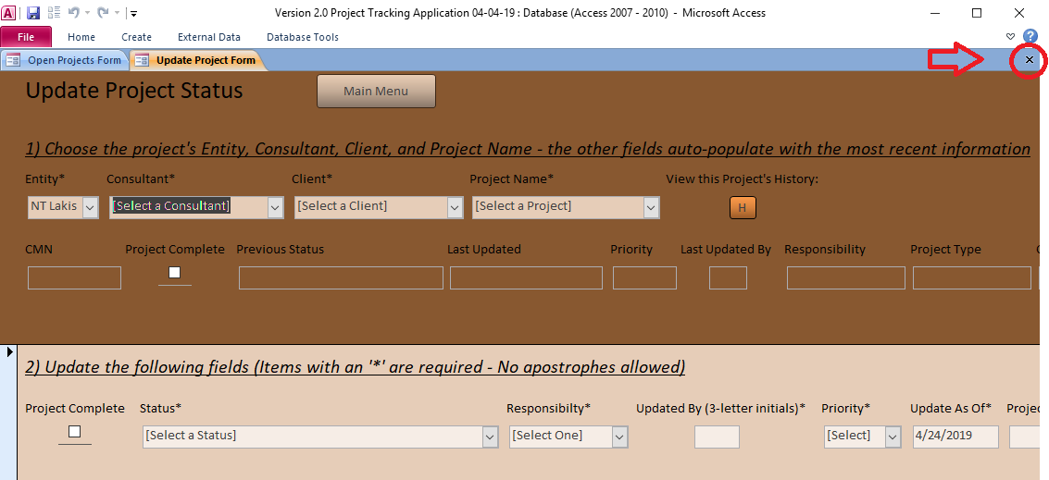If you have multiple forms open and would like to close one, click the small black “x” on the right (see below). If you close out of all forms, however, you will need to close and re-open the database to restore functionality.

# Troubleshooting

1. Have you enabled the database? See the section *Start-Up*. You may need to click ‘Reload Application’.
2. Have you clicked ‘Reload Form’ on the Form you are working on?
3. The best troubleshooting option is to close the database and re-open it again.
4. If the issue persists, document it and then reach out to James and Christina for assistance.

# Field Definitions

* Analyst(s) – The one or two analysts working on a project.
  + The ‘Add New Project Form’ allows you to specify who the First Analyst is and who the Second Analyst is.
* Client – Name of the client.
* Client Number – The number associated with a particular client, depending upon whether the projects are under NT Lakis or EASI. See ‘Entity’.
* CMN – Client Matter Number. This is a combination of the four-digit Client Number and the four-digit Matter Number.
* Complete – A checkbox indicating if the project is complete.
  + Checking the box will remove the project from the initial view of the Open Projects Form, Consultants Form, Clients Form, and Analysts Form. You can however make it reappear by toggling the checkbox titled “Current Projects Only” on the form.
  + Word of note: Do not check the ‘Complete’ checkbox for a project’s status until you are 100% sure the project is complete.
* Consultant(s) – The one or two consultants working on a project.
  + The ‘Add New Project Form’ allows you to specify who the First Consultant is and who the Second Consultant is.
* Entity – Whether this is an NT Lakis or an EASI project. All EASI clients have the client number 1310, while NT Lakis clients must not have the same client number.
* Last Update – The date specified in the last status update. This is *not* necessarily when someone input the status, however.
* Last Updated By – The initials of whoever updated that project’s status.
* Matter Number – Synonymous with Project Number, this is the number for a specific project. Project numbers can be the same between NT Lakis clients but must be different between EASI clients.
* Priority – The project’s current priority according to the Consultant, SME, or Manager. The options are High, Medium, Low, or Hold (if the project has finished but you would not like to check ‘Project Complete’ yet).
* Project Name – Name of the project. Synonymous with ‘Matter Name’.
* Project Status Notes – Miscellaneous notes about a project’s status.
  + You can type in this field up to the standard Access memo limit, although only the first few words of the text will appear in the forms.
  + Avoid using apostrophes
* Project Type – May be abbreviated as ‘Proj. Type’. The following Project Types are recognized:
  + EEO-1/VETS (for EEO-1 and VETS-4212 reports)
  + AAP
  + Comp (for Compensation-related projects)
  + Audit
  + Ratings
  + Other
* Responsible – Who is responsible to take action next on the project? Synonymous with ‘Ball in Whose Court’. The options are SME, Analyst, Client, and OFCCP.
* Status – The project’s status. The statuses available for a project depend on its Project Type i.e. you can only choose statuses related to EEO-1/VETS projects or All projects for an EEO-1/VETS project.